Wyatt Duberstein

Problem 1, Query 1:

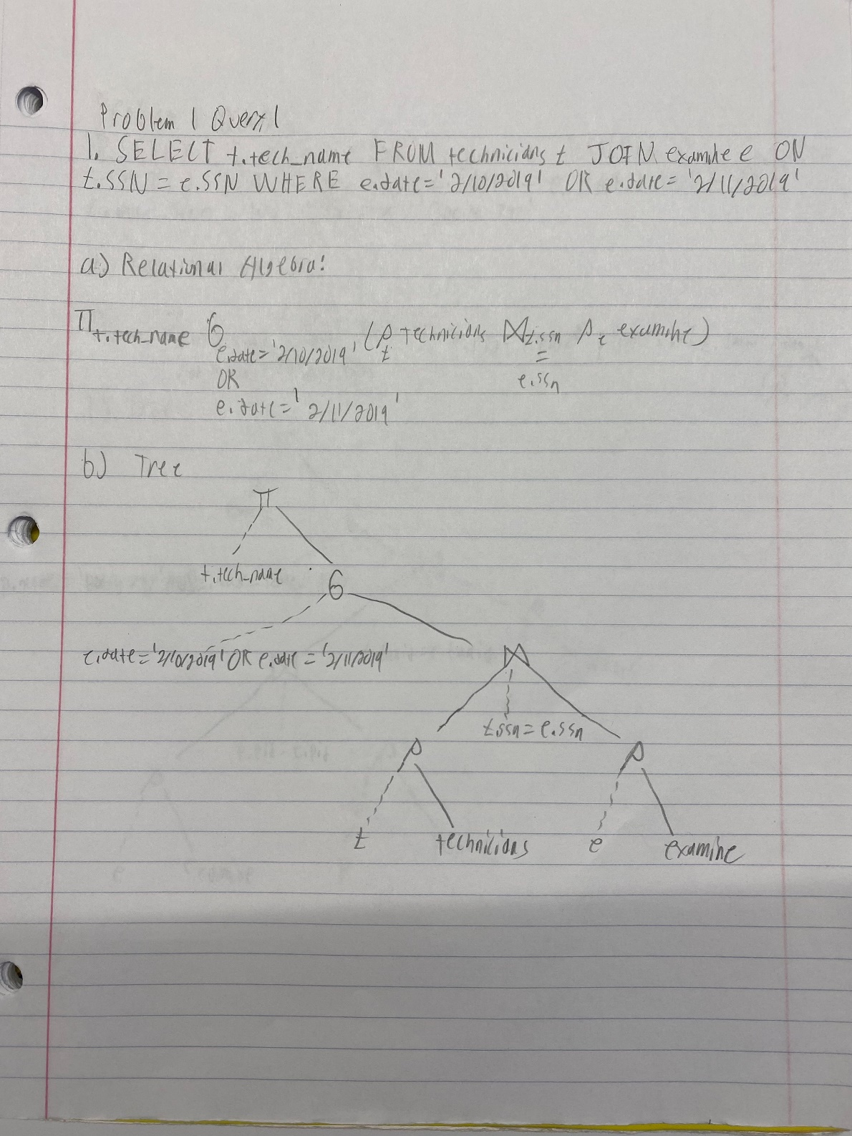

Problem 1, Query 2:

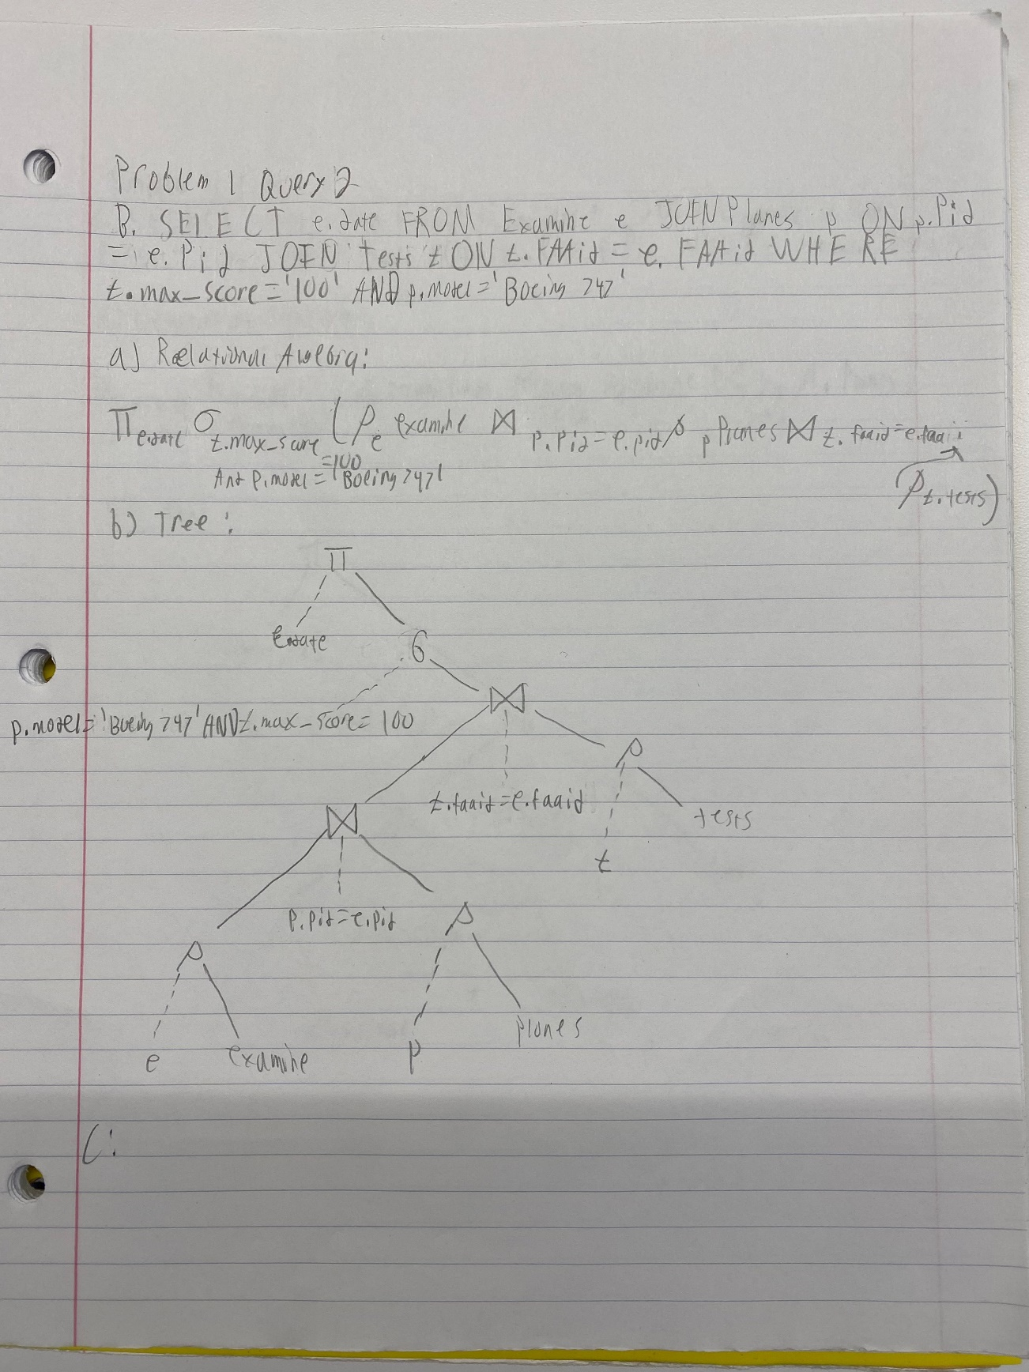

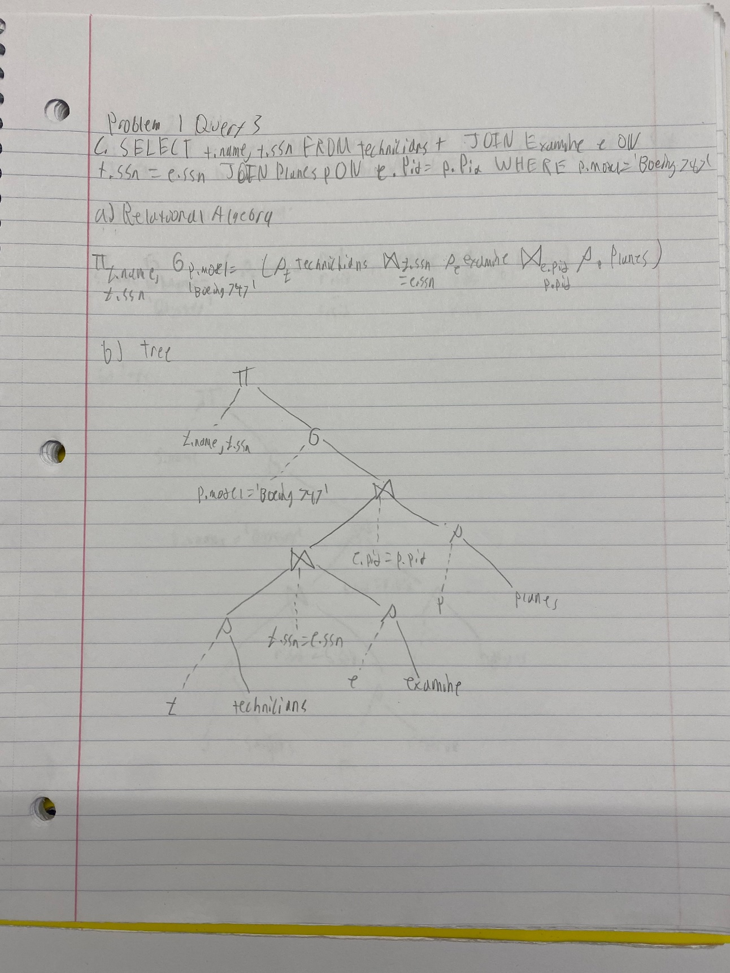Problem 1, Query 3:

Problem 1, Part C:

Since there are 4 tables, then 4! = 24 left-deep join trees. We can only include 12 of those because some of the tables don’t have common attributes with other tables.

Problem 2, Query 1:

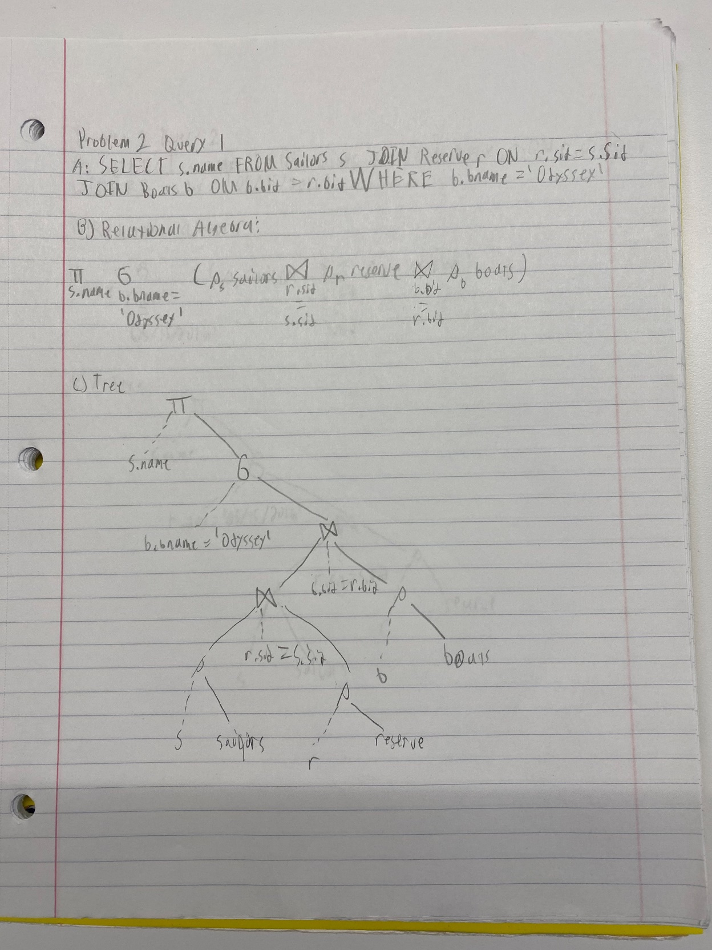

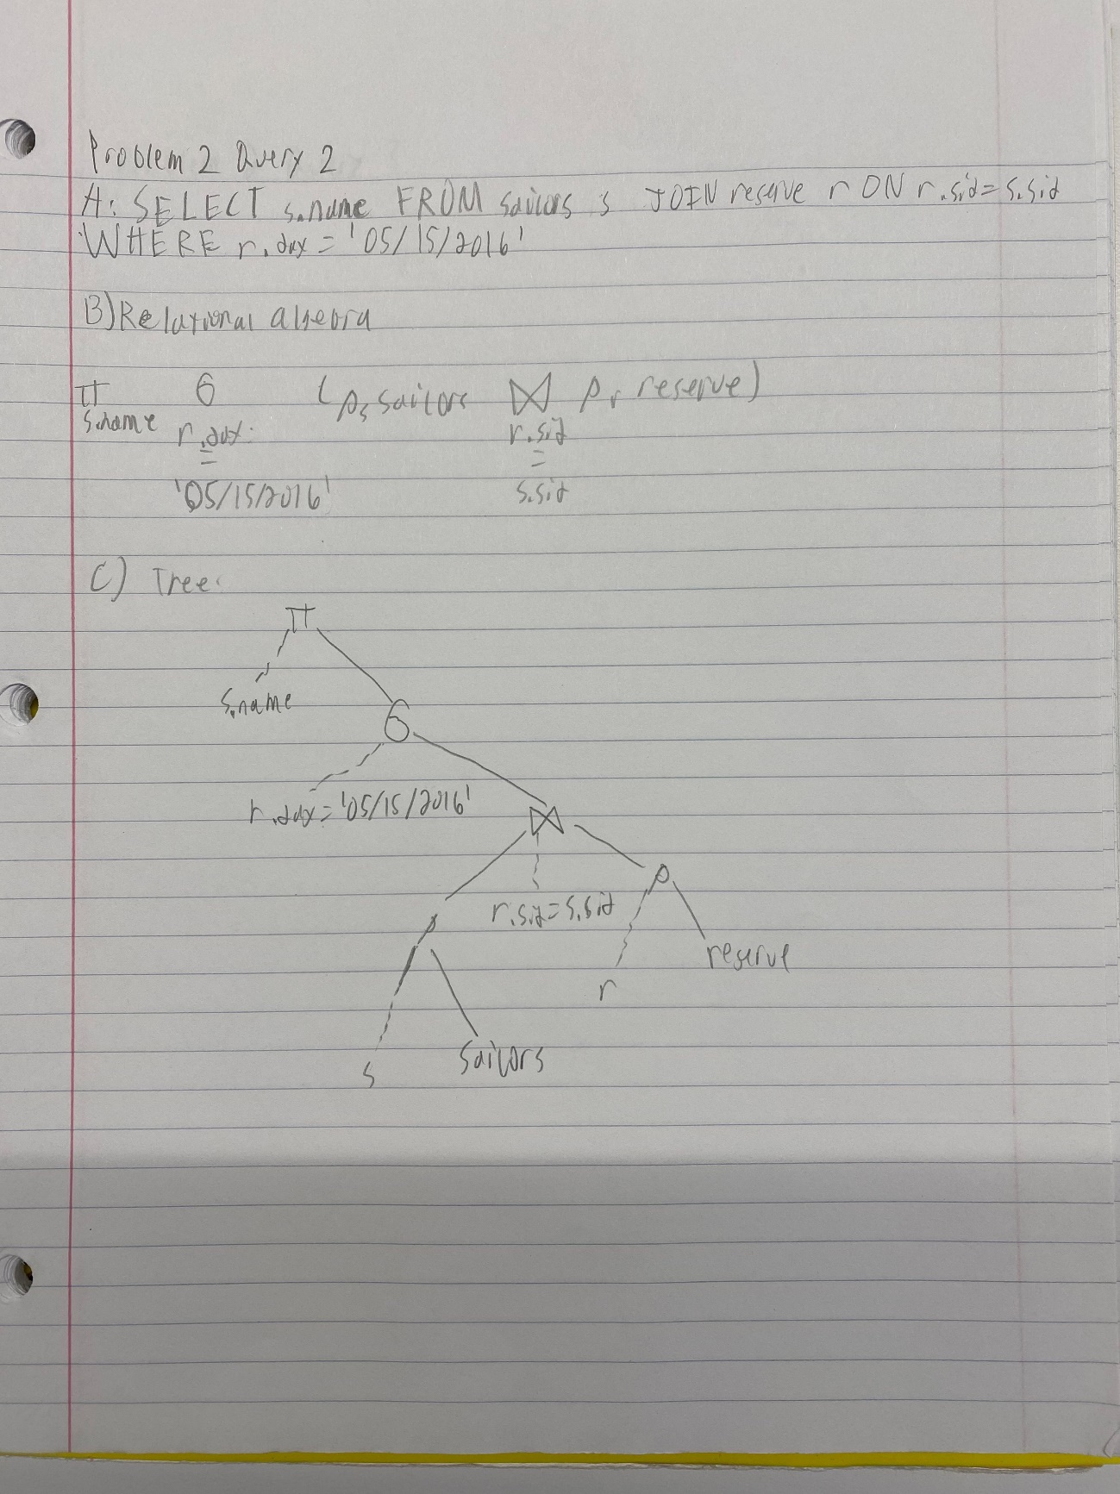Problem 2, Query 2:

Problem 2, Query 3:

